Filed pursuant to Rule 425 under the

Securities Act of 1933, as amended, and

deemed filed under Rule 14a-12 under the

Securities Exchange Act of 1934, as amended

Filer: ON SEMICONDUCTOR CORP

Commission File No.: 000-49602

Subject Company: Synaptics Incorporated
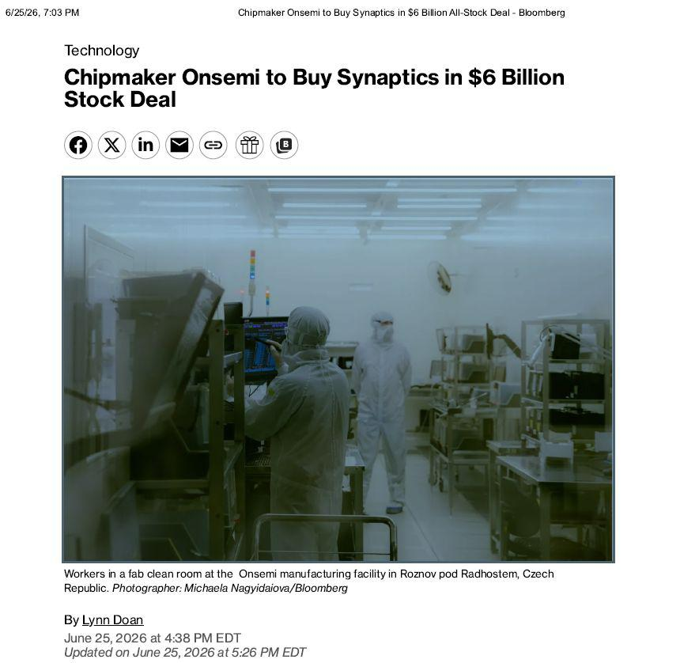

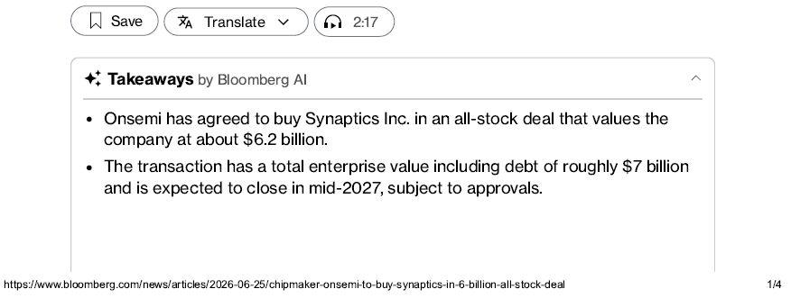

Tech n ob og y

Chipmaker Onsemi to Buy Synaptiics in $6 Bil l ion Stoick DealWoikeis i n a fab cb ean ioom at th e On sem i m an u factu ii n g faci b i ty i n Rozn ov pod Radh ostem , Czech Repu bb i cZ Photographer: Michaela Nagyidaiova/BloombergB y Ly n n D oan

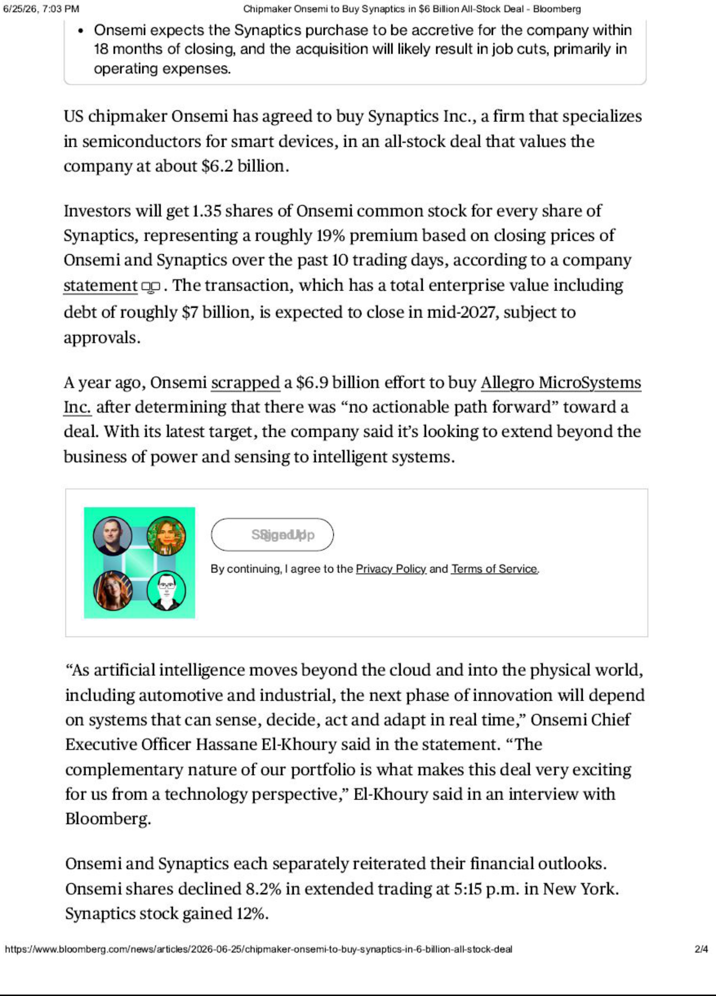

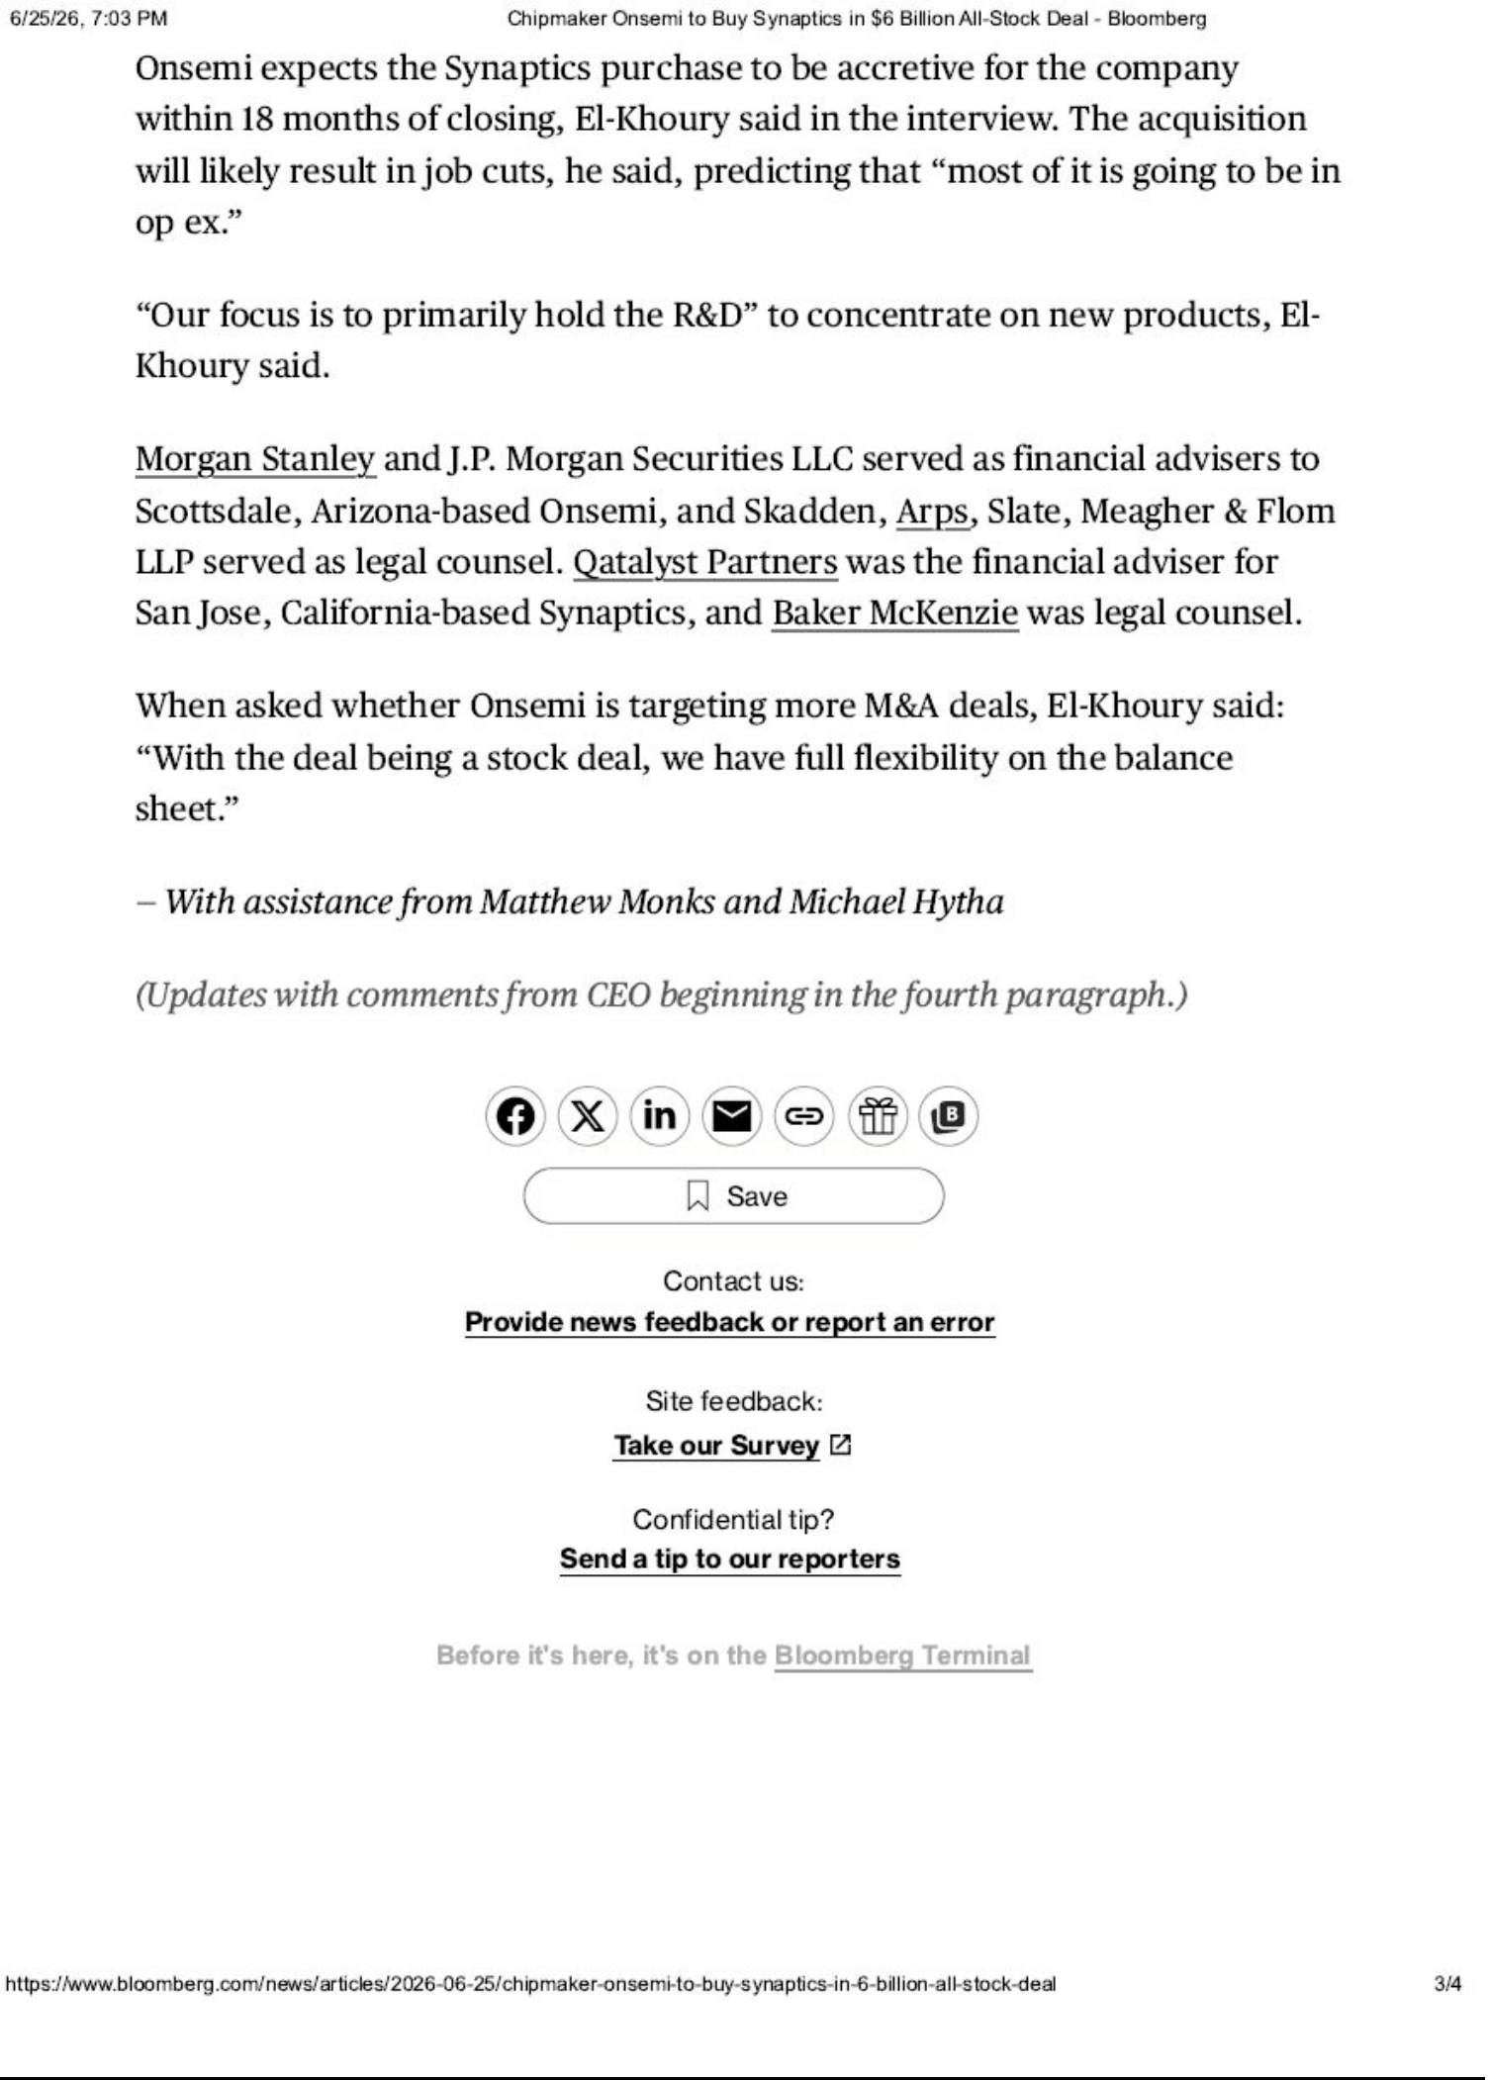

Cautionary Note Regarding Forward-Looking Statements

This communication relates to a proposed business combination transaction between Synaptics Incorporated and ON Semiconductor Corporation. This communication includes forward-looking statements within the meaning of Section 27A of the Securities Act of 1933, as amended, and Section 21E of the Securities Exchange Act of 1934, as amended. These forward-looking statements are based on Synaptics’ and onsemi’s current expectations, estimates and projections about the expected date of closing of the proposed transaction and the potential benefits thereof, their respective businesses and industries, management’s beliefs and certain assumptions made by Synaptics and onsemi, all of which are subject to change. Some of these forward-looking statements can be identified by the use of forward-looking words such as “believes,” “expects,” “may,” “will,” “should,” “seeks,” “approximately,” “intends,” “plans,” “estimates,” “projects,” “strategy,” or “anticipates,” or the negative of those words or other comparable terminology that convey uncertainty of future events or outcomes.

These forward-looking statements involve known and unknown risks and uncertainties, which may cause Synaptics’ or onsemi’s actual results and performance to be materially different from those expressed or implied in the forward-looking statements. Factors and risks that may impact future results and performance include, but are not limited to, the following factors: (1) the risk that the conditions to the closing of the transaction are not satisfied, including the risk that required approvals from regulators or the stockholders of Synaptics for the transaction are not obtained; (2) litigation relating to the transaction; (3) uncertainties as to the timing of the consummation of the transaction and the ability of each party to consummate the transaction; (4) risks that the proposed transaction disrupts the current plans and operations of Synaptics or onsemi, including restrictions during the pendency of the transaction that may impact the ability to pursue certain business opportunities or strategic transactions; (5) the ability of Synaptics and onsemi to retain and hire key personnel; (6) competitive responses to the proposed transaction; (7) unexpected costs, charges or expenses resulting from the transaction; (8) potential adverse reactions or changes to business relationships resulting from the announcement or completion of the transaction; (9) the combined companies’ ability to achieve the growth prospects and synergies expected from the transaction, as well as delays, challenges and expenses associated with integrating the combined companies’ existing businesses; (10) uncertainty as to the long-term value of onsemi’s common stock; (11) legislative, regulatory and economic developments; and (12) unpredictability and severity of catastrophic events, including, but not limited to, acts of terrorism or outbreak of war or hostilities, as well as Synaptics’ and onsemi’s response to any of the aforementioned factors. These risks, as well as other risks associated with the proposed transaction, will be more fully discussed in the proxy statement/prospectus that will be included in the Registration Statement on Form S-4 that will be filed with the SEC in connection with the proposed transaction. While the list of factors presented here is considered representative, no such list should be considered to be a complete statement of all potential risks and uncertainties. Unlisted factors may present significant additional obstacles to the realization of forward-looking statements.

In addition, actual results are subject to other risks and uncertainties that relate more broadly to Synaptics’ overall business, including those more fully described in Synaptics’ filings with the Securities and Exchange Commission (“SEC”) including its annual report on Form 10-K for the fiscal year ended June 28, 2025, and its quarterly reports filed on Form 10-Q for the current fiscal year, and onsemi’s overall business and financial condition, including those more fully described in onsemi’s filings with the SEC including its annual report on Form 10-K for the fiscal year ended December 31, 2025, and its quarterly reports filed on Form 10-Q for its current fiscal year. Forward-looking statements are not guarantees of performance, and speak only as of the date made, and neither Synaptics nor its management undertakes any obligation to update or revise any forward-looking statements.

No Offer or Solicitation

This communication is for informational purposes only and does not constitute, or form a part of, an offer to buy or sell or the solicitation of an offer to buy or sell any securities, or a solicitation of any vote or approval, nor shall there be any sale of securities in any jurisdiction in which such offer, solicitation or sale would be unlawful prior to registration or qualification under the securities laws of any such jurisdiction. No offer of securities shall be made except by means of a prospectus meeting the requirements of Section 10 of the Securities Act of 1933, as amended.

Important Additional Information about the Transaction and Where To Find It

The proposed transaction will be submitted to the stockholders of Synaptics for their consideration. In connection with the proposed transaction, onsemi will file with the SEC a Registration Statement on Form S-4 that will include a proxy statement of Synaptics and that also constitutes a prospectus of onsemi. Each of Synaptics and onsemi will provide the proxy statement/prospectus to Synaptics stockholders. Synaptics and onsemi also plan to file other documents with the SEC regarding the proposed transaction. This document is not a substitute for any prospectus, proxy statement or any other document which Synaptics or onsemi may file with the SEC in connection with the proposed transaction. INVESTORS AND SECURITY HOLDERS ARE URGED TO READ THE PROXY STATEMENT/PROSPECTUS AND ANY OTHER RELEVANT DOCUMENTS THAT WILL BE FILED WITH THE SEC CAREFULLY AND IN THEIR ENTIRETY WHEN THEY BECOME AVAILABLE BECAUSE THEY WILL CONTAIN IMPORTANT INFORMATION ABOUT THE PROPOSED TRANSACTION. You may obtain copies of all documents filed with the SEC regarding this transaction, free of charge, at the SEC’s website (www.sec.gov). In addition, investors and stockholders will be able to obtain free copies of the proxy statement/prospectus and other documents filed with the SEC by the parties on Synaptics Investor Relations at https://investor.synaptics.com/ (for documents filed with the SEC by Synaptics) or onsemi Investor Relations at https://investor.onsemi.com/ (for documents filed with the SEC by onsemi).

Participants in the Solicitation

Synaptics, onsemi, and certain of their respective directors, executive officers and other members of management and employees, under SEC rules may be deemed to be participants in the solicitation of proxies from Synaptics stockholders in connection with the proposed transaction. Information regarding the persons who may, under the rules of the SEC, be deemed participants in the solicitation of Synaptics stockholders in connection with the proposed transaction, and a description of their direct and indirect interests, by security holdings or otherwise, will be set forth in the proxy statement/prospectus when it is filed with the SEC. You can find more detailed information about Synaptics’ executive officers and directors under the headings “Proposal 1 – Election of Directors,” “Director Compensation,” “Compensation Discussion and Analysis,” “Named Executive Officer Compensation Tables,” “CEO Pay Ratio Disclosure,” “Pay Versus Performance Disclosure” and “Beneficial Ownership of Certain Stockholders” in its definitive proxy statement filed with the SEC on September 16, 2025. To the extent holdings of Synaptics common stock by the directors and executive officers of Synaptics have changed from the amounts of Synaptics common stock held by such persons as reflected therein, such changes have been or will be reflected on Statements of Change in Ownership on Form 4 filed with the SEC, which are available at https://www.sec.gov/edgar/browse/?CIK=817720&owner=exclude under the tab “Ownership Disclosures”. You can find more detailed information about onsemi’s executive officers and directors under the headings “The Board of Directors and Corporate Governance,” “Compensation of Executive Officers” and “Stock Ownership” in its definitive proxy statement filed with the SEC on April 2, 2026. To the extent holdings of onsemi common stock by the directors and executive officers of onsemi have changed from the amounts of onsemi common stock held by such persons as reflected therein, such changes have been or will be reflected on Statements of Change in Ownership on Form 4 filed with the SEC, which are available at https://www.sec.gov/edgar/browse/?CIK=1097864&owner=exclude under the tab “Ownership Disclosures”. Additional information about Synaptics’ executive officers and directors and onsemi’s executive officers and directors can be found in the above-referenced Registration Statement on Form S-4 when it becomes available.

